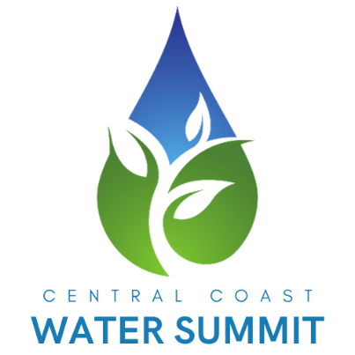

FOR IMMEDIATE RELEASE
March 2024
Haley Georgalos, Marketing Coordinator
K&D Landscaping, Inc.
831-728-4018
marketing@kndlandscaping.com

A Powerful Gathering: 4th Annual Central Coast Water Summit Unites 200 Industry Leaders for Innovation and Action
Watsonville, CA – March 14, 2025 – The 4th Annual Central Coast Water Summit was nothing short of electrifying! With 200 industry leaders, innovators, and changemakers in attendance, this year’s event delivered powerful conversations, cutting-edge solutions, and an energy that will fuel progress long after the final session.
“The Central Coast Water Summit isn’t just about discussions—it’s about action,” said Justin White, CEO of K&D Landscaping and founder of JW Group. “Seeing 200 industry leaders come together, share solutions, and push the boundaries of what’s possible in water conservation is truly inspiring.”
From the moment the doors opened, the room buzzed with excitement as attendees connected with top-tier exhibitors showcasing the latest breakthroughs in water efficiency, smart irrigation, and sustainable landscape management. The momentum only grew as our lineup of expert speakers took the stage, delivering insights that challenged the status quo and inspired action.
Key Highlights from the Summit:
✅ Engaging Speaker Sessions: Industry heavyweights Justin Black (City of Roseville), Justin White (CEO of K&D Landscaping and founder of JW Group), Kevin Battistoni (Hunter Industries), Michael Johnson (California H2orticulture Services) and Ben Mason (Weathermatic) shared game-changing strategies on the future of water conservation, tackling drought challenges, and adopting smarter irrigation technology.
✅ Powerful Networking: Attendees forged new partnerships and strengthened industry relationships, creating a ripple effect of collaboration beyond the event.
✅ Innovative Exhibitor Showcases: The expo floor was packed with the latest products and technologies revolutionizing water management—giving attendees firsthand access to tools that can make an immediate impact.
With this level of engagement and enthusiasm, the countdown to next year’s event has already begun! Mark your calendars: The 5th Annual Central Coast Water Summit returns on March 12, 2026. Expect even bigger conversations, more groundbreaking solutions, and the same unbeatable energy that makes this event a must-attend for industry leaders.
🚀 Be part of the movement. Stay tuned for updates at www.kndlandscaping.com and follow us on social media for exclusive content, speaker highlights, and ways to get involved.
For interviews or additional inquiries, please contact:

K&D Landscaping
marketing@kndlandscaping.com
831-728-4018

