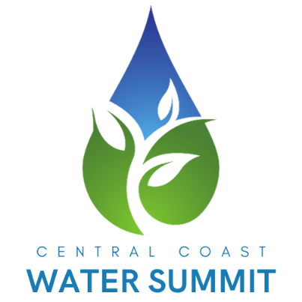

FOR IMMEDIATE RELEASE
January 2024
Haley Georgalos, Marketing Coordinator
K&D Landscaping, Inc.
831-728-4018
marketing@kndlandscaping.com

K&D Water Management Presents the 4th Annual Central Coast Water Summit
Santa Cruz, CA — Mark your calendars for Thursday, March 13, 2025, as K&D Water Management proudly hosts the 4th Annual Central Coast Water Summit at the iconic Boardwalk’s Cocoanut Grove, located at 400 Beach Street, Santa Cruz, CA. The event will run from 8:00 AM to 4:00 PM and promises a day of inspiration, innovation, and actionable insights into water conservation and sustainability.
This year’s Summit invites industry leaders, visionaries, and changemakers to share groundbreaking solutions for one of the most pressing challenges of our time: sustainable water management. Attendees can expect dynamic panel discussions, interactive exhibits, and unparalleled networking opportunities designed to empower attendees with fresh ideas that make a real impact.
Key Highlights of the Event:
- Expert Speakers: Justin White of K&D Landscaping and JW Group, Kevin Battistoni of Hunter Industries, and additional industry thought leaders.
- Interactive Opportunities: Dive into exhibits showcasing top innovations in water management.
- Professional Growth: CEUs will be available for certified irrigation technicians.
- Networking Opportunities: Build meaningful connections with industry leaders and peers passionate about water sustainability.
Who Should Attend?
The Summit is designed for:
- Landscape and irrigation professionals
- Contractors
- Property managers
- Homeowners
- Students
- HOA boards
Whether you’re seeking innovative ideas, professional growth, or meaningful connections, this event is a must-attend for anyone passionate about sustainability and water management.
Register Today!
Tickets and sponsorships are now available at https://kndlandscaping.com/. Don’t miss this opportunity to be part of the conversation shaping the future of water conservation.
About K&D Landscaping:
K&D Landscaping is a premier landscaping company based in Watsonville, specializing in sustainable landscaping solutions. Their innovative and environmentally friendly approach has earned them recognition as industry leaders in water management and landscaping design.

For interviews or additional inquiries, please contact:

K&D Landscaping
marketing@kndlandscaping.com
831-728-4018

