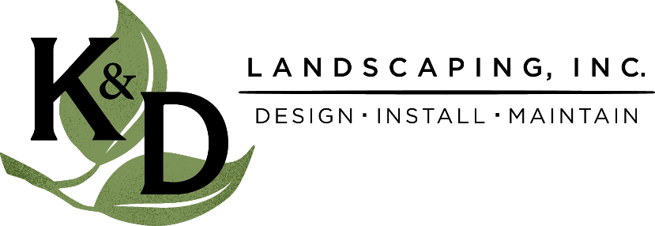
FOR IMMEDIATE RELEASE
December 8, 2021
Lelah Welfring
K&D Landscaping, Inc.
(831)854-3003
lelah@kndlandscaping.com

Local landscape company takes home five state trophy awards

Watsonville based company, K&D Landscaping, receives top honors at 2021 CLCA State Beautification Awards

MAUI, HI --- NOVEMBER 5, 2021 --- K&D Landscaping won five State Trophy Awards at the annual California Landscape Contractors Association (CLCA) Convention this year, which took place in Maui, HI. The convention showcases the best of the best in landscaping across the state, including commercial, residential and maintenance projects and properties.

Claiming just one of these trophies is a huge feat in itself for a company in the landscape industry. With hundreds of entries, the competition for excellence is fierce.

K&D Landscaping won the following five awards:
- Large Commercial Installation, 1st Place
- Large Commercial Installation, Outstanding Achievement
- Large Residential Maintenance, Outstanding Achievement
- Bob Baier Memorial Award for Best Residential Landscaping Under $150k
- Gary Vallen Memorial Award for Best Entry Containing Sustainable Installation Elements

K&D has been recognized for their commitment in giving back with multiple accolades throughout the community. They have received several awards of excellence from the California Landscape Contractors Association, including the Nelson Colvin Humanitarian Award for a previous Community Beautification project. They were honored as the 2020 Business of the Year by the Pajaro Valley Chamber of Commerce, were bestowed the Volunteer Center's Be the Difference Award in 2019 and are on target to create 300 local jobs by 2030!

About California Landscape Contractors Association (CLCA)
“CLCA’s mission is to serve and protect the interests of its members, promote professionalism, and advance public awareness of the landscape industry.”

About K&D Landscaping, Inc.
K&D Landscaping has been serving the local area for over three decades. The company started with just one truck and a lawnmower but has since developed into a successful and growing landscaping business on the Central Coast. With the goal of creating functional and beautiful outdoor living areas for both residential and commercial clients, this company is experiencing explosive growth that shows no signs of slowing down. For more information, please visit https://kndlandscaping.com/ or call (831)728-4018.

For media inquiries, contact Lelah Welfring at (831)854-3003; lelah@kndlandscaping.com

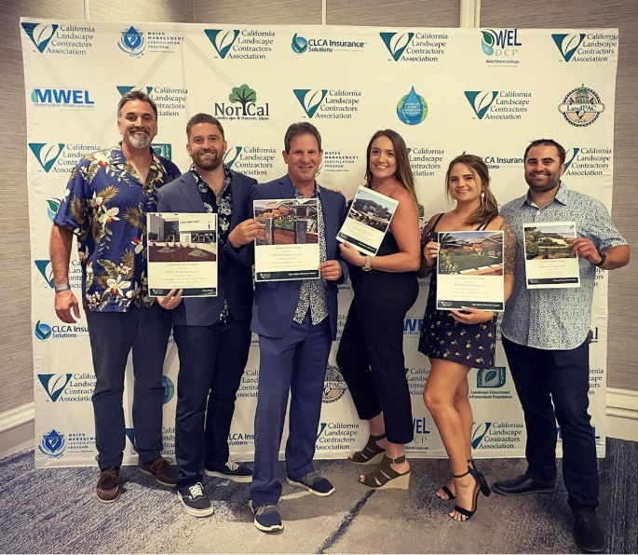

K&D Landscaping at the 2021 CLCA State Trophy Awards

