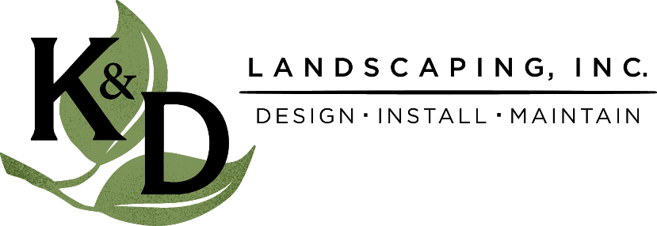
FOR IMMEDIATE RELEASE
December 7, 2021
Lelah Welfring
K&D Landscaping, Inc.
(831)854-3003
lelah@kndlandscaping.com

Central Coast landscape company partners with county department to revamp park entrance

Santa Cruz County Parks Department receives facelift to Hidden Beach Park entrance from charitable landscape company
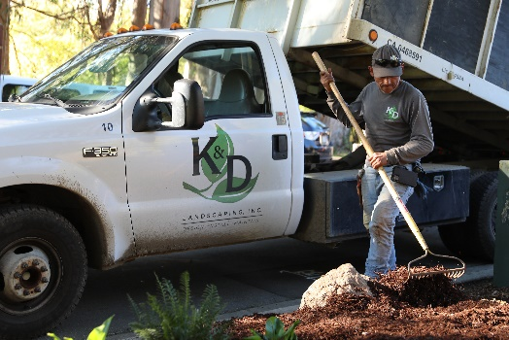
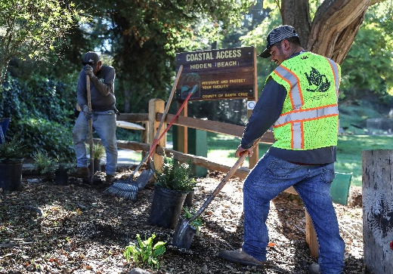
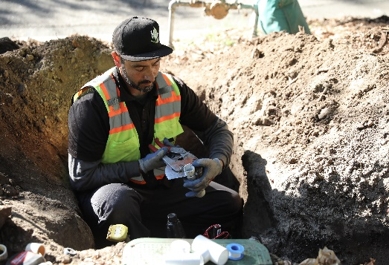

* Additional photos from the Hidden Beach Beautification project available upon request.

APTOS, CA --- NOVEMBER 15, 2021 --- Santa Cruz County Parks Department was gifted an outdoor upgrade to the Aptos Hidden Beach (660 Cliff Dr.) entrance from K&D Landscaping Inc. as part of their Community Beautification program.

The company devoted both labor and materials free of charge, with contribution help from a few close-relationship vendors, El Paraiso Nursery and Vision Recycling. Ground improvements included installation of drip irrigation, native planting with gopher baskets and fresh mulch.

Michael Hettenhausen from Santa Cruz County Parks commented on the collaboration, “The park visitors to the playground are awarded a newly landscaped park entrance thanks to their generosity. K&D Landscaping is such an asset to the community.”

The sprucing up of the park’s entry was in junction with a larger community fundraiser to renovate the playground in memory of a local boy, Jett Ramsey, who lost his battle to cancer last year. Along with the Santa Cruz County Parks Department, nonprofit County Park Friends and several other generous donators rallied together to enhance the park for future generations to enjoy.

“Seeing the community come together to create an inclusive playground in honor of Jett Ramsey was heartwarming,” mentioned K&D Landscaping’s Project Manager, Darlene Beal. She added, “Working with local, native plants to enhance the habitat is always a plus!”
K&D has been recognized for their commitment in giving back with multiple accolades throughout the community. They have received several awards of excellence from the California Landscape Contractors Association, including the Nelson Colvin Humanitarian Award for a previous Community Beautification project. They were honored as the 2020 Business of the Year by the Pajaro Valley Chamber of Commerce, were bestowed the Volunteer Center's Be the Difference Award in 2019 and are on target to create 300 local jobs by 2030!

For additional insight into K&D’s Community Beautification program, visit https://kndlandscaping.com/community-beautification/.

About Santa Cruz County Parks
“Since 1979, the Santa Cruz County Parks Department has managed a diverse parks system including neighborhood and regional parks, coastal access points, trails, and cultural and recreational programs for all ages throughout the unincorporated county. The County of Santa Cruz Department of Parks, Open Space and Cultural Services mission is to provide safe, well-designed and maintained parks, and a wide variety of recreational and cultural opportunities for our diverse community.”

About K&D Landscaping, Inc.
K&D Landscaping has been serving the local area for over three decades. The company started with just one truck and a lawnmower but has since developed into a successful and growing landscaping business on the Central Coast. With the goal of creating functional and beautiful outdoor living areas for both residential and commercial clients, this company is experiencing explosive growth that shows no signs of slowing down. For more information, please visit https://kndlandscaping.com/ or call (831)728-4018.

For media inquiries, contact Lelah Welfring at (831)854-3003; lelah@kndlandscaping.com

