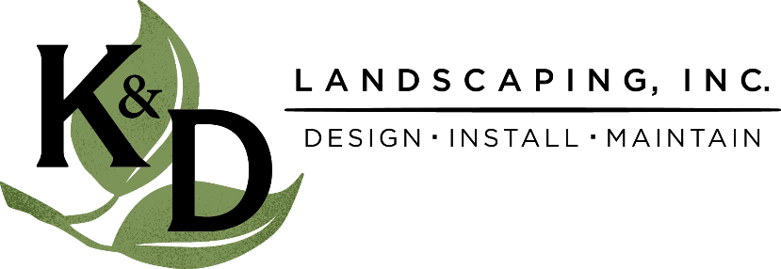
FOR IMMEDIATE RELEASE
June 2023
K&D Landscaping
(831) 728-4018
marketing@kndlandscaping.com

Seascape Beach Resort and K&D Landscaping: Pioneers in Water Conservation Featured on National Magazine Cover

APTOS, CA --- JUNE 20, 2023 --- Seascape Beach Resort in Aptos, in collaboration with K&D Landscaping of Watsonville, has made waves in the field of water conservation. Their remarkable achievement of saving 1 Million Gallons of Water has garnered them national recognition. The duo's success is the focal point of the latest issue of Irrigation and Lighting, a prestigious national magazine.

Seascape Beach Resort and K&D Landscaping joined hands with a shared vision – to promote water sustainability while enhancing the lush landscapes that have become a hallmark of the Central Coast. Their journey is not only an environmental triumph but also a testament to the economic and innovative advantages of water management, making the partnership a game-changer in the industry.

The Impact of K&D Landscaping's Water Management on Seascape Resort
Seascape Beach Resort, nestled on the picturesque Central Coast, has long been admired for its stunning natural beauty. However, this year, the resort and K&D Landscaping have taken their commitment to environmental responsibility to new heights. By working hand-in-hand with K&D Landscaping, Seascape Resort has achieved the monumental feat of conserving 1 million gallons of water.

K&D Landscaping implemented cutting-edge irrigation solutions and lighting techniques, all tailored to the unique needs of Seascape Resort's landscaping. This strategic and efficient approach not only helped reduce water usage but also improved the overall aesthetic appeal of the resort's gardens, ultimately enhancing the guest experience.

Leveraging Future Business and Innovation in Water Management
Seascape Beach Resort and K&D Landscaping's partnership showcases the practical benefits of investing in landscape irrigation systems. Not only does this collaboration champion sustainability and preserve our precious natural resources, but it also signifies a forward-thinking approach to landscaping and water management.

The success story of Seascape Beach Resort and K&D Landscaping serves as an inspiration for other businesses and communities on the Central Coast. In an era where water conservation is of paramount importance, this collaboration underscores the economic feasibility of making responsible choices for our environment.

By investing in advanced irrigation systems and landscaping solutions, local businesses can not only reduce their ecological footprint but also attract environmentally conscious customers, thus strengthening their market presence and profitability.

This momentous achievement by Seascape Beach Resort and K&D Landscaping also highlights the Central Coast's potential as a hub for innovation in water management. It reinforces the region's capacity to lead in sustainability and environmental stewardship.

For more information, interviews, or inquiries, please contact:

K&D Landscaping
Email: marketing@kndlandscaping.com
Phone: 831-728-4018

About Seascape Beach Resort:
Seascape Beach Resort, located in the heart of the Central Coast, is an idyllic retreat known for its stunning oceanfront location and eco-friendly practices. With a deep commitment to environmental responsibility, Seascape Resort has set a new standard for sustainable tourism.

About K&D Landscaping:
K&D Landscaping is a premier landscaping company based in Watsonville, specializing in sustainable landscaping solutions. Their innovative and environmentally friendly approach has earned them recognition as industry leaders in water management and landscaping design.

